**Introduction**

Myopia is the leading cause of correctable visual impairment and preventable blindness worldwide [1]. According to 2019 statistics, there weas about 22% prevalence of myopia worldwide at the beginning of the 21st century. By 2019, the number had risen to 33%. It was estimated that the prevalence of myopia will rise to 52% in 2050 [2]. There is no doubt that myopia has become a serious health problem in recent years.

We noticed that the majority of students in the international department at Beijing National Day School (BNDS) are wearing glasses. We have also heard many adults tell us to reduce the use of electronic devices to protect our eyes. We wonder what is the correlation between the time usage of electronic devices and the degree of myopia. We performed an observational study in the BNDS international department.

This observational study helps to reveal whether there is a correlation between the degree of myopia and the usage time of electronic devices in the BNDS international department. We will make a chi-square test for independence; The null hypothesis is that there is no correlation between the degree of myopia and the use time of electronic devices. The alternative hypothesis is that there is a correlation between the degree of myopia and the use time of electronic devices. We also construct a Least Square Regression Line (LSRL) for the degree of myopia and the time of electronic device use and construct a confidence interval for the slope of the regression line.

**Methods and Procedures**

Data collection: We collect our data from the Wen Juan Xing(WJX) link. We first collected the name of all three grade students in the international department. We got 634 available names and labeled them through 1-634. We used a random number generator to generate 90 different numbers. We ignore the numbers that have been chosen and the numbers other than 1-634. The corresponding students will be our samples. We sent the WJX link through Wecom privately. Here is the population and corresponding samples:

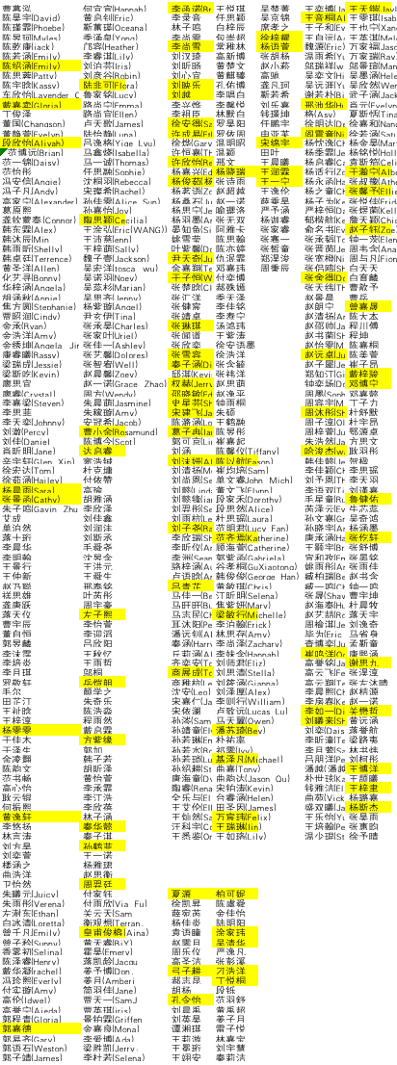

In the WJX questionnaire, we asked their average time of electronic devices use and their degree of myopia. Then we put our table into a two-way table:

We made a chi-square test for independence to test correlation between the degree of myopia and the usage time of electronic devices:

Then, we used the data to construct a LSRL:

We also constructed a 95 confidence interval for the slope of the regression line:

**Results**

**Discussion and further suggestions**

**Conclusions**

**References**

[1]Assem, Abel Sinshaw, Mebratu Mulusew Tegegne, and Sofonias Addis Fekadu. "Prevalence and associated factors of myopia among school children in Bahir Dar city, Northwest Ethiopia, 2019." *PLoS One* 16.3 (2021): e0248936.

[2]Batista Filho, Malaquias. "The worldwide challenge on myopia." Revista Brasileira de Saúde Materno Infantil 19 (2019): 509-510.